Building and Securing a Vulnerable Web Application:
A Full Security Lifecycle Case Study
Collin Gamble
PRO390 – Capstone Project
Degree: Information Systems & Cybersecurity
Neumont University
February 2026

Table of Contents
1. Executive Summary 5
2. Project Overview 5
3. System Architecture & Technology Stack 7
3.1 System Architecture Overview 7
3.2 Security Middleware Stack 9
3.3 Security Design Philosophy 10
3.4 Environment & Testing Infrastructure 10
4. Intentional Vulnerability Design (Week 4) 11
4.1 Purpose of the Vulnerability Phase 11
4.2 Vulnerability 1: NoSQL Injection (Authentication Bypass) 11
4.3 Vulnerability 2: Stored Cross-Site Scripting (XSS) 12
4.4 Vulnerability 3: Account Enumeration via Verbose Error Messages 13
4.5 Vulnerability 4: Insecure Session Cookie Configuration (Lab Mode) 14
4.6 Summary of Vulnerability Phase 14
5. Controlled Exploitation & Impact (Week 5) 15
5.1 Purpose of the Exploitation Phase 15
5.2 Exploitation Scenario 1: NoSQL Injection Authentication Bypass 15
5.3 Exploitation Scenario 2: Stored Cross-Site Scripting (XSS) 18
5.4 Exploitation Scenario 3: Account Enumeration 19
5.5 Exploitation Scenario 4: Chained Attack (XSS + Insecure Session Cookies) 22
5.6 Exploitation Phase Summary 23
6. Remediation Engineering & Secure Implementation (Week 6) 23
6.1 Purpose of the Remediation Phase 23
6.2 Remediation Overview Table 24
6.3 NoSQL Injection Remediation 24
6.4 Stored XSS Remediation 25
6.5 Account Enumeration Remediation 25
6.6 Session Security Hardening 26
6.7 Brute-Force Mitigation (Rate Limiting) 26
6.8 Defense-in-Depth Strategy 27
6.9 Remediation Phase Summary 27
7. Security Validation & Retesting (Week 7) 28
7.1 Purpose of the Validation Phase 28
7.2 Validation Scenario 1: NoSQL Injection Prevention 28
7.3 Validation Scenario 2: Stored XSS Mitigation 31
7.4 Validation Scenario 3: Account Enumeration Prevention 33
7.5 Validation Scenario 4: Session Security Hardening 35
7.6 Validation Scenario 5: Rate Limiting Enforcement 36
7.7 Security Posture Comparison 37
8. Threat Modeling Analysis (STRIDE Framework) 37
8.1 Purpose of Threat Modeling 37
8.2 System Boundaries & Attack Surface 38
8.3 STRIDE Category Analysis 39
8.4 STRIDE Summary Table 42
8.5 Threat Modeling Phase Summary 43
9. Automated Security Validation (OWASP ZAP – Week 8) 43
9.1 Purpose of Automated Validation 43
9.2 Testing Methodology 44
9.3 Initial Scan Results 44
9.4 Medium-Risk Findings (Configuration-Level) 45
9.5 CSP Hardening & Revalidation 47
9.6 Validation of Previously Exploited Vulnerabilities 48
9.7 Security Posture Comparison 48
9.8 Automated Validation Summary 49
10. Final Security Posture Assessment 49
10.1 Security Lifecycle Summary 49
10.2 Defense-in-Depth Evaluation 50
10.3 Alignment with OWASP Top 10 51
10.4 Residual Risk Considerations 51
10.5 Professional Evaluation 52
11. Lessons Learned 52
11.1 Technical Growth 52
11.2 Security Mindset Development 53
11.3 Understanding Chained Risk 53
12. Conclusion 53
13. AI Assistance Disclosure 54

1. Executive Summary
This Capstone project demonstrates the complete security lifecycle of a full-stack web application through the intentional introduction, exploitation, remediation, and validation of common web vulnerabilities. The project involved building a banking-style web application using Node.js, Express, MongoDB, and EJS templates in a controlled local environment.
After developing core functionality, including user registration, authentication, fund transfers, transaction history, and role-based administrative access. intentional vulnerabilities were introduced. This included NoSQL injection, stored cross-site scripting (XSS), verbose authentication error messages enabling account enumeration, and insecure session cookie configuration.
Each vulnerability was exploited in a controlled testing phase using tools such as Postman and web browser developer tools. Attack impact was documented through screenshots and logs to demonstrate real-world consequences such as authentication bypass, persistent script execution, account discovery, and potential session hijacking.
Following controlled exploitation, structured remediation strategies were implemented. Security controls including strict input validation, output encoding, CSRF protection, rate limiting, express-mongo-sanitize, Helmet security headers, and hardened session configuration were applied. Previously successful attack payloads were re-executed to confirm mitigation effectiveness.
The application was further evaluated using the STRIDE threat modeling framework and automated scanning via OWASP ZAP. Automated validation confirmed the absence of high-risk vulnerabilities and demonstrated measurable security posture improvement following configuration hardening.
The final result is a fully documented case study illustrating offensive security testing, defensive engineering practices, layered security implementation, and formal validation methodology within a contained lab environment.

2. Project Overview
The purpose of this Capstone project was to gain hands-on experience in both offensive and defensive web application security within a safe and controlled environment. Rather than solely building a functional web application, the objective was to simulate realistic development mistakes, exploit those weaknesses, and then systematically secure the system.
The application was designed as a simplified online banking prototype containing synthetic user data. Core features included:
- User registration and login
- Account dashboard displaying mock financial information
- Transfer funds functionality with transaction logging
- Transaction history view
- Role-based administrative access
All development and testing occurred locally on localhost using a Node.js/Express server and a local MongoDB database. The application was never exposed to the internet, and no real financial data was used.
The project intentionally introduced vulnerabilities aligned with the OWASP Top 10 to demonstrate:
- How injection attacks occur
- How client-side script execution compromises users
- How authentication logic flaws expose account data
- How insecure configuration enables session abuse
After documenting exploit behavior, mitigations were engineered using secure coding principles and industry best practices. The final phases focused on validation, automated testing, and proactive threat modeling to demonstrate comprehensive security lifecycle coverage.
This report presents the full progression from vulnerability introduction to validated security hardening.

3. System Architecture & Technology Stack

3.1 System Architecture Overview
The Capstone application was designed as a simplified banking-style web application operating entirely within a controlled local environment. The system follows a traditional three-tier architecture:
- Client Layer (Presentation Layer)
- Application Layer (Server Logic)
- Data Layer (Database)
All components run locally on http://localhost:3000 and interact over HTTP. The application was never deployed publicly and was intentionally isolated to ensure safe vulnerability testing.
Client Layer
The front end uses:
- EJS (Embedded JavaScript Templates)
- HTML5
- CSS3
- Client-side JavaScript (minimal)
EJS templates dynamically render user-specific data such as account balances, transaction history, and administrative views. During the vulnerability phase, output rendering behavior was intentionally manipulated to demonstrate stored XSS risk. In the remediation phase, output encoding was restored and verified.
The client browser also serves as the primary interaction point for:
- Authentication flows
- Session cookie storage
- CSRF token handling
- Rendering of transaction metadata

Application Layer
The backend was built using:
- Node.js
- Express.js
- express-session
The Express server handles:
- Authentication and authorization
- Transfer logic and transaction recording
- Role-based access control
- Middleware enforcement (security controls)
- Session management
Routes are protected using session-based authentication checks and role validation middleware for administrative access.
During the secure implementation phase, the application layer incorporated layered security controls including:
- CSRF protection (csurf)
- Rate limiting (express-rate-limit)
- MongoDB query sanitization (express-mongo-sanitize)
- Security headers via Helmet
- Hardened session configuration

Data Layer
The database uses:
- MongoDB (local instance)
The users collection stores:
- Username
- Hashed password (bcrypt)
- Account number
- Balance
- Transaction history
- Role (user/admin)
- Email and phone number
- lastLogin timestamp
All data is synthetic and generated either manually or through seed scripts. No real financial data was used at any point.
Database interactions are handled using controlled query logic with strict type validation implemented during remediation to prevent operator injection.

3.2 Security Middleware Stack
Following remediation, the application implemented a layered middleware architecture designed to mitigate multiple classes of attack simultaneously.
Implemented Security Controls
Control | Purpose
bcrypt | Secure password hashing
express-mongo-sanitize | Prevent NoSQL operator injection
csurf | CSRF protection for POST routes
express-rate-limit | Brute-force mitigation
Helmet | HTTP security headers & CSP
express-session | Secure session management
HttpOnly + SameSite cookies | Session hijacking mitigation
This layered model ensures that no single vulnerability fix is relied upon exclusively. Instead, multiple defensive controls operate simultaneously to reduce exploit feasibility.

3.3 Security Design Philosophy
The secure version of the application was engineered using a defense-in-depth strategy. Rather than relying on a single control (e.g., escaping output), multiple layers of protection were implemented:
- Input validation
- Output encoding
- Query sanitization
- Session hardening
- Rate limiting
- Error message normalization
- Security header enforcement
This approach reduces both direct exploitability and the ability to chain vulnerabilities together.

3.4 Environment & Testing Infrastructure
All development and testing occurred within a controlled local lab environment using:
- Node.js runtime
- MongoDB local instance
- Postman (API testing)
- Browser DevTools
- OWASP ZAP 2.17.0 (Desktop)
- Git for version control
The system was never deployed externally, ensuring ethical and contained vulnerability testing.

4. Intentional Vulnerability Design (Week 4)

4.1 Purpose of the Vulnerability Phase
Following completion of core application functionality, the system was intentionally modified to include security weaknesses aligned with the OWASP Top 10. The objective was to simulate common real-world development mistakes in a controlled environment and later validate mitigation effectiveness.
Each vulnerability was:
- Intentionally introduced
- Clearly documented
- Mapped to OWASP categories
- Designed to be realistically exploitable
- Isolated within a local lab configuration
This phase transformed the functional prototype into a controlled vulnerability lab.

4.2 Vulnerability 1: NoSQL Injection (Authentication Bypass)
OWASP Mapping: A03 – Injection
Severity (Lab Context): High
Design Intent
The authentication logic was intentionally modified to allow MongoDB query operators to be injected via user input. The goal was to demonstrate how improper type handling in NoSQL environments can lead to authentication bypass.
Root Cause
The vulnerable authentication endpoint passed user input directly into a MongoDB query without enforcing strict data types.
Simplified example:
usersCollection.findOne({ username, password });
If username and password were provided as objects instead of strings, MongoDB interpreted them as operators rather than literal values.
For example:
{
"username": { "$ne": null },
"password": { "$ne": null }
}
This caused MongoDB to match the first user in the database, bypassing credential verification.
Intended Impact
- Authentication bypass without valid credentials
- Issuance of valid session cookie
- Access to protected routes
- Full account compromise
This vulnerability was intentionally exposed via a dedicated /login-vuln endpoint active only in lab mode.

4.3 Vulnerability 2: Stored Cross-Site Scripting (XSS)
OWASP Mapping: A03 – Injection
Severity (Lab Context): Medium–High
Design Intent
The transfer memo field was intentionally rendered using raw HTML output to demonstrate persistent client-side script execution.
Root Cause
The transactions page used unescaped EJS output:
<%- tx.description %>
The <%- %> syntax renders content without escaping, allowing JavaScript execution if malicious input is stored.
Intended Impact
- Persistent JavaScript execution
- Stored payload execution on page load
- Potential session cookie theft (if cookies insecure)
- Chained attack opportunity
This vulnerability was intentionally crafted to later demonstrate defense-in-depth when combined with insecure session configuration.

4.4 Vulnerability 3: Account Enumeration via Verbose Error Messages
OWASP Mapping: A07 – Identification & Authentication Failures
Severity (Lab Context): Medium
Design Intent
The authentication and password recovery workflows were modified to return distinct error messages depending on internal account state.
Example:
if (!user) {
return res.render("login", { error: "User not found." });
}
if (!match) {
return res.render("login", { error: "Incorrect password." });
}
This allowed attackers to differentiate between:
- Nonexistent usernames
- Valid usernames with incorrect passwords
- Email mismatches in password recovery
Intended Impact
- Username discovery
- Email association discovery
- Reduced attack surface complexity for brute-force attempts
- Target preparation for credential stuffing
While not immediately granting access, this vulnerability significantly lowered the barrier for further exploitation.

4.5 Vulnerability 4: Insecure Session Cookie Configuration (Lab Mode)
OWASP Mapping: A05 – Security Misconfiguration
Severity (Lab Context): Medium
Design Intent
Session cookie security was intentionally weakened when running in lab mode to demonstrate how client-side script execution could expose session identifiers.
In lab configuration:
httpOnly: false
This allowed the session cookie (connect.sid) to be accessed via:
document.cookie
Intended Impact
- Session identifier exposure
- Potential session hijacking
- Privilege escalation if admin session stolen
- Demonstration of chained attack risk when combined with XSS

4.6 Summary of Vulnerability Phase
By the end of Week 4, the application intentionally contained:
Vulnerability | OWASP Category | Intended Risk
NoSQL Injection | A03 Injection | Authentication bypass
Stored XSS | A03 Injection | Client-side compromise
Account Enumeration | A07 Auth Failures | Account discovery
Insecure Session Cookies | A05 Misconfiguration | Session hijacking
The system was now prepared for controlled exploitation.

5. Controlled Exploitation & Impact (Week 5)

5.1 Purpose of the Exploitation Phase
After intentionally introducing vulnerabilities in Week 4, controlled attack testing was conducted to simulate realistic attacker behavior and validate exploit feasibility. This phase aimed to:
- Confirm each vulnerability was practically exploitable
- Document impact with visual evidence
- Demonstrate real-world consequences
- Establish a baseline prior to remediation
All testing was performed locally using Postman and web browser developer tools. No external systems were involved.

5.2 Exploitation Scenario 1: NoSQL Injection Authentication Bypass
OWASP Category: A03 – Injection
Tool Used: Postman
Severity Demonstrated: High
Attack Execution
A POST request was sent to the intentionally vulnerable /login-vuln endpoint using the following payload:
{
"username": { "$ne": null },
"password": { "$ne": null }
}
MongoDB interpreted the injected operators as query logic rather than literal values. The query matched the first user in the database and returned a successful authentication result.
Impact Observed
- Authentication succeeded without valid credentials
- A valid connect.sid session cookie was issued
- Access to protected routes was granted
- Full dashboard data became accessible

Screenshot: Postman Post Login page.jpg
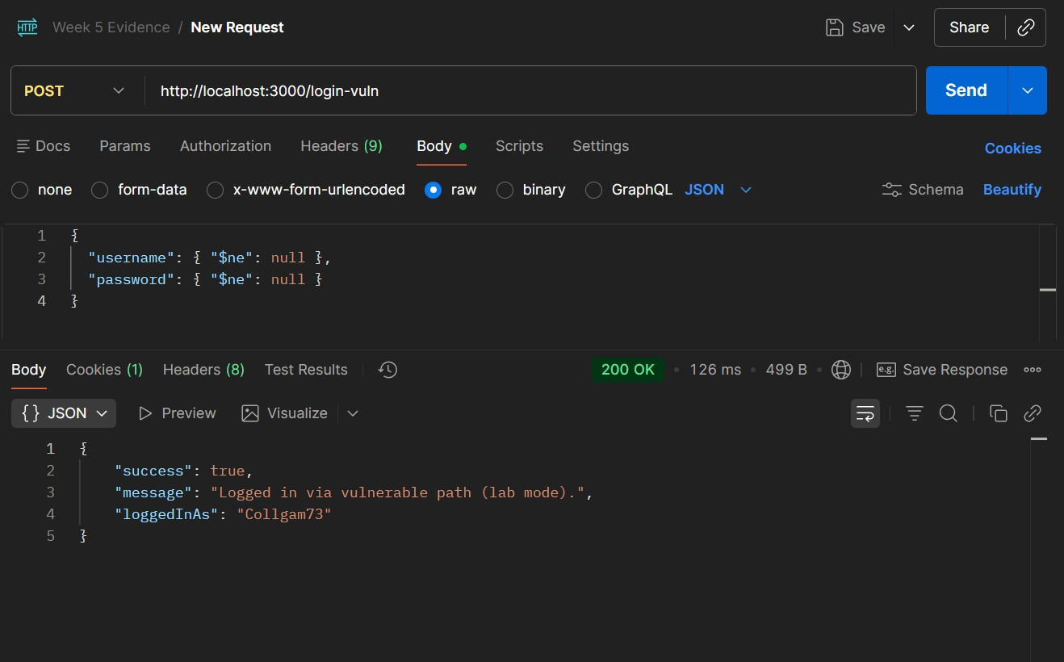
(Capture showing injection payload and successful authentication response)

Screenshot: Postman Cookies.jpg
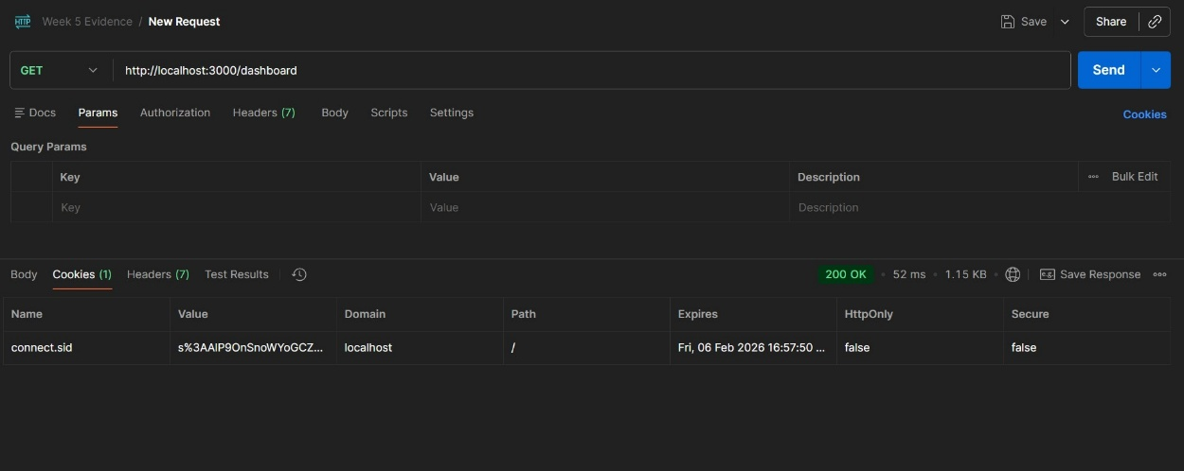
(Capture showing valid session cookie issuance)

Screenshot: Postman Get Dashboard Request.jpg
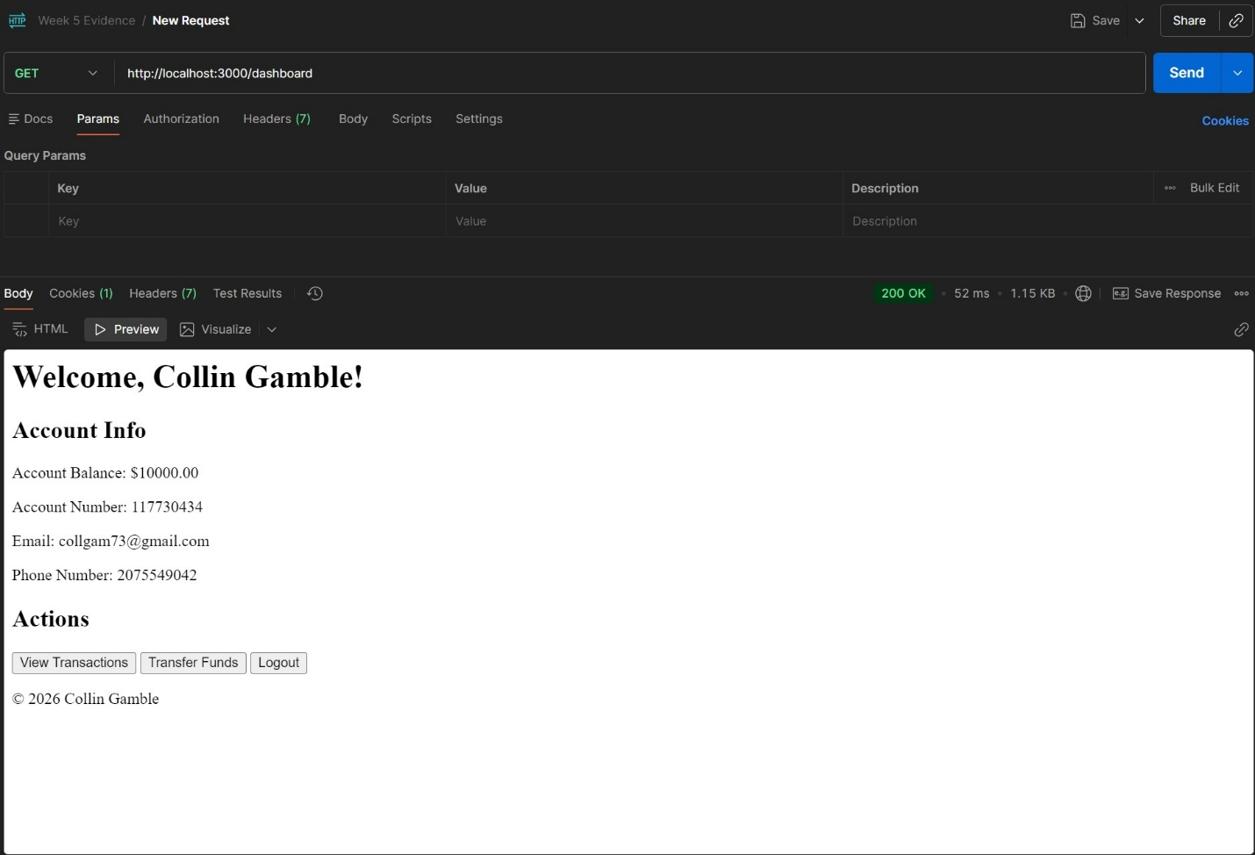
(Capture showing successful access to protected dashboard route)

Security Impact
This vulnerability completely bypassed authentication controls, allowing unauthorized access to:
- Account balances
- Account numbers
- Personal metadata
- Transfer functionality
This demonstrated a full authentication compromise.

5.3 Exploitation Scenario 2: Stored Cross-Site Scripting (XSS)
OWASP Category: A03 – Injection
Tool Used: Web Browser
Severity Demonstrated: Medium–High
Attack Execution
A malicious payload was submitted through the transfer memo field:
<img src=x onerror="alert('Stored XSS')">
The payload was stored in the database and rendered unescaped on the transactions page.
Impact Observed
- JavaScript executed automatically upon page load
- Browser alert popup confirmed script execution
- Payload persisted across sessions
- Potential for session hijacking (if cookies insecure)

Screenshot: Website Showed Memo XSS.jpg
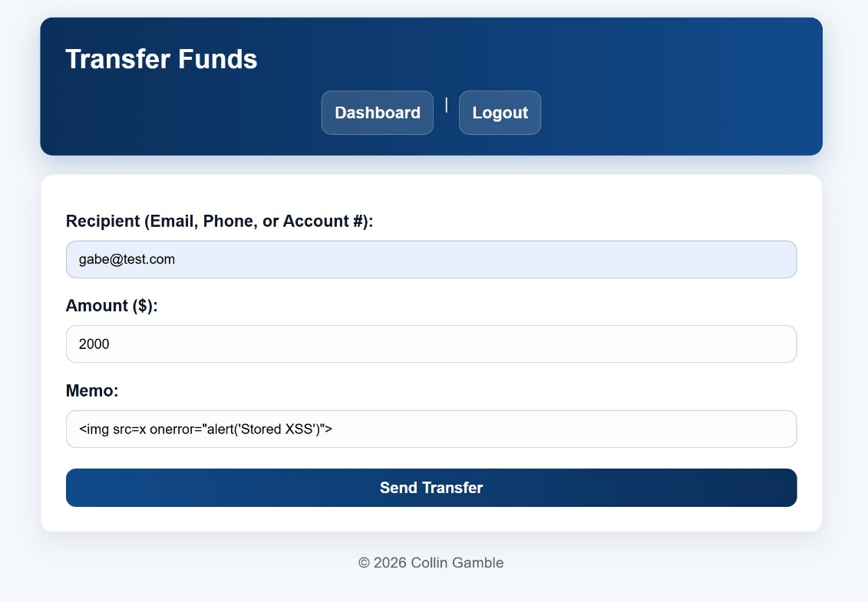
(Capture showing malicious memo stored in transaction history)
Screenshot: Website XSS Alert on Transactions Page.jpg
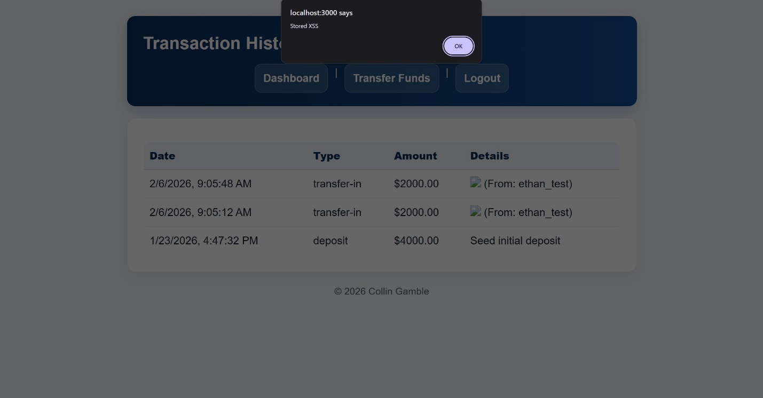
(Capture showing alert popup triggered by stored XSS)

Security Impact
Stored XSS enabled arbitrary JavaScript execution in the user’s browser. While this did not directly bypass authentication, it created a platform for:
- Session cookie theft
- UI manipulation
- Credential harvesting
- Chained exploitation

5.4 Exploitation Scenario 3: Account Enumeration
OWASP Category: A07 – Identification & Authentication Failures
Tool Used: Web Browser
Severity Demonstrated: Medium
Attack Execution – Login Workflow
Distinct error messages were returned depending on authentication failure condition:
- “User not found.”
- “Incorrect password.”
This allowed confirmation of valid usernames.

Screenshot: Website Username not found error.jpg
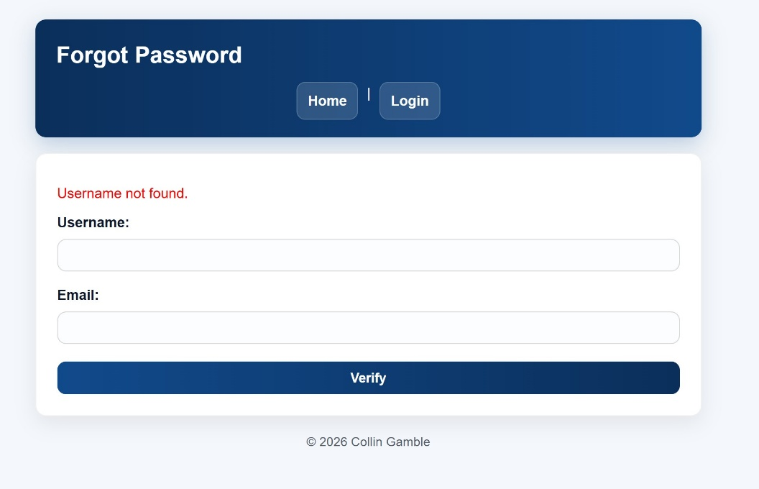
Screenshot: Website Wrong password error.jpg
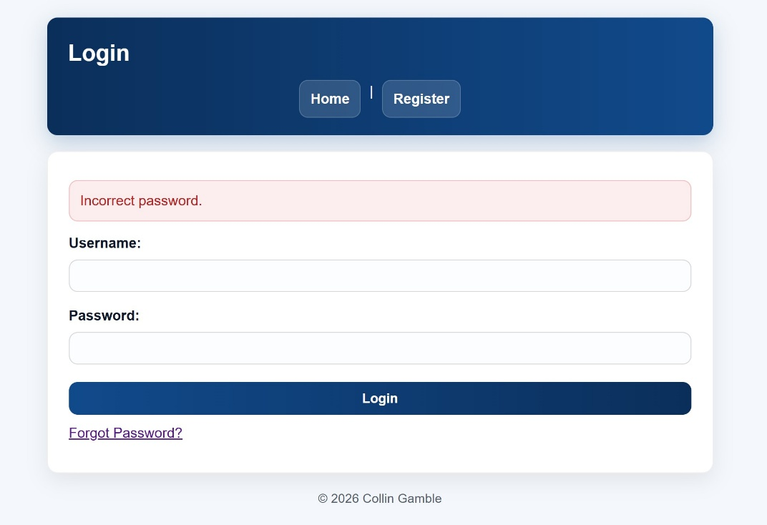
Attack Execution – Forgot Password Workflow
The password recovery endpoint returned:
- “Username not found.”
- “Email does not match this username.”
This allowed attackers to determine whether specific emails were associated with accounts.

Screenshot: Website User not found error.jpg
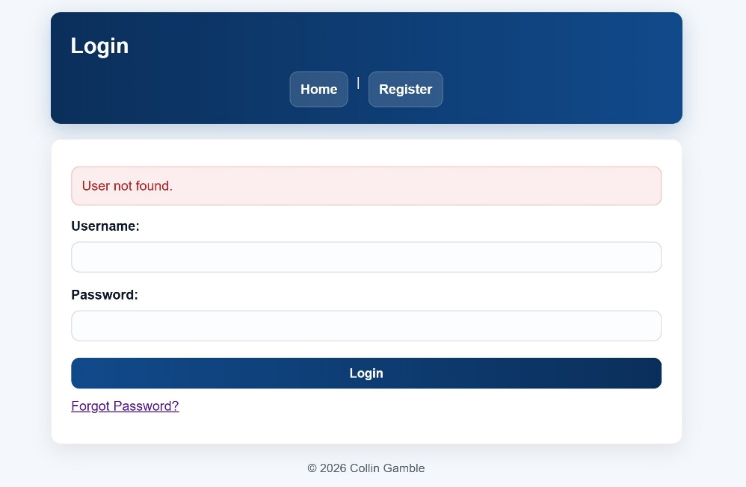
Screenshot: Website Email does not match username error.jpg
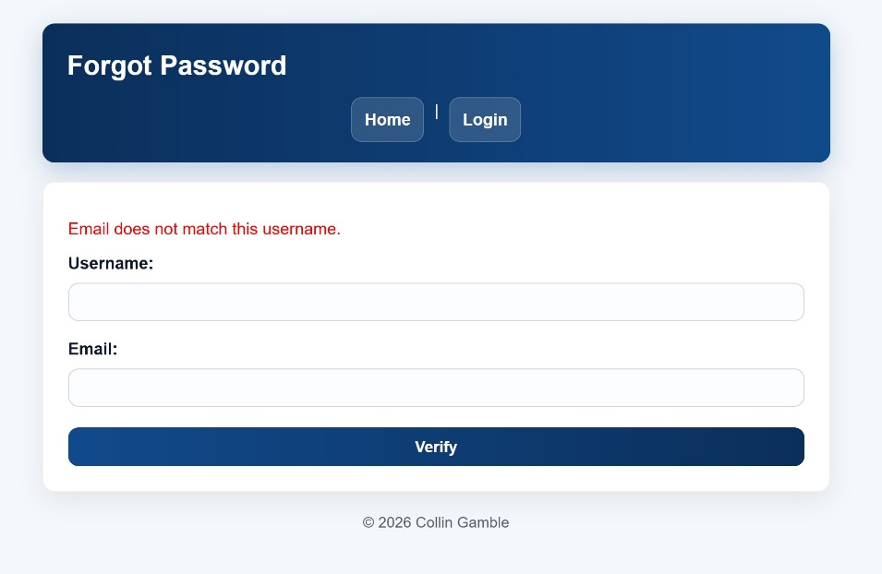
Security Impact
Although this vulnerability did not directly grant unauthorized access, it:
- Exposed valid account identifiers
- Reduced brute-force complexity
- Enabled targeted credential attacks

5.5 Exploitation Scenario 4: Chained Attack (XSS + Insecure Session Cookies)
OWASP Category: A05 – Security Misconfiguration
Attack Chain
- Stored XSS executed on the transactions page
- document.cookie was accessed
- Session identifier was exposed
Because the HttpOnly flag was disabled in lab mode, the session cookie could be read by client-side JavaScript.

Screenshot: Capstone Website Cookies connectsid after.jpg
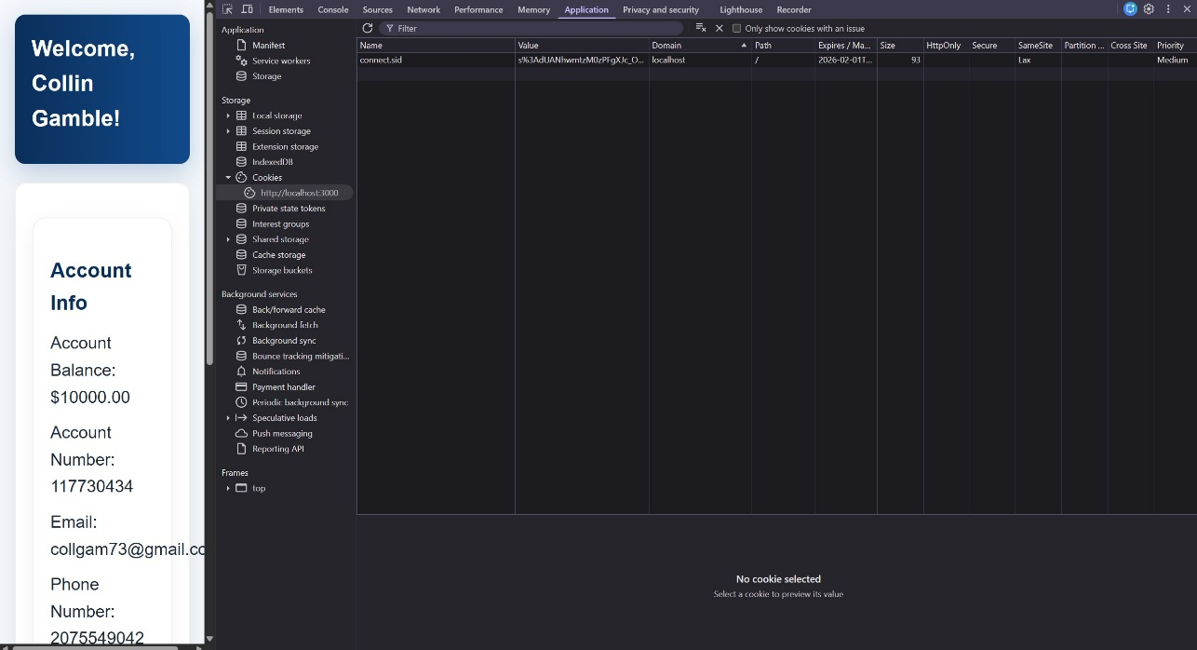
(Capture showing session cookie without HttpOnly flag)
Security Impact
This demonstrated defense failure at multiple layers:
- Client-side injection allowed script execution
- Insecure cookie configuration allowed session exposure
- Combined risk enabled potential account takeover
This chained attack emphasized the importance of layered security controls rather than isolated fixes.

5.6 Exploitation Phase Summary
By the end of Week 5, all intentionally introduced vulnerabilities were successfully exploited and documented. The system demonstrated:
- Authentication bypass
- Persistent script execution
- Account discovery
- Session exposure
This established a measurable baseline prior to remediation.

6. Remediation Engineering & Secure Implementation (Week 6)

6.1 Purpose of the Remediation Phase
Following controlled exploitation in Week 5, the application entered a structured remediation phase. The objective was not simply to patch visible symptoms, but to eliminate root causes and introduce layered defensive controls aligned with modern secure coding practices.
This phase focused on:
- Eliminating injection vectors
- Preventing client-side script execution
- Removing sensitive information disclosure
- Hardening session security
- Introducing rate limiting controls
- Implementing middleware-based security enforcement
All remediation work was performed locally and validated through regression testing.

6.2 Remediation Overview Table
The table below summarizes each vulnerability, its root cause, and the mitigation strategy implemented.
Vulnerability | Root Cause | Remediation Strategy | Verification Outcome
NoSQL Injection | Unsafe query construction | Strict input typing + express-mongo-sanitize | Injection blocked
Stored XSS | Unescaped output rendering | Escaped EJS output + CSP headers | Script execution prevented
Account Enumeration | Verbose authentication errors | Generic error messaging | Enumeration eliminated
Insecure Session Cookies | HttpOnly disabled | HttpOnly + SameSite enforced | Cookie inaccessible to JS
Brute-Force Attempts | No request throttling | express-rate-limit | 429 enforcement confirmed
This structured approach ensured that each exploit demonstrated in Week 5 was directly addressed.

6.3 NoSQL Injection Remediation
Root Cause Addressed
The vulnerable authentication endpoint allowed MongoDB operator injection due to unsafe type handling.
Mitigations Implemented
- Removed the intentionally vulnerable /login-vuln endpoint
- Enforced strict string validation of authentication inputs
- Implemented express-mongo-sanitize to strip MongoDB operators from request bodies
- Normalized authentication error messaging
- Integrated CSRF protection to prevent forged login requests
Security Improvement
Injection payloads were no longer interpreted as query operators. Attempts to inject $ne or other operators were sanitized or rejected before reaching the database layer.

6.4 Stored XSS Remediation
Root Cause Addressed
The transactions page rendered user-controlled input using unescaped EJS syntax.
Mitigations Implemented
- Replaced raw rendering <%- %> with escaped rendering <%= %>
- Reviewed all EJS templates for unsafe output patterns
- Implemented Helmet middleware for HTTP security headers
- Introduced Content Security Policy Configuration
Security Improvement
Injected scripts were rendered as inert text rather than executable code. Even if rendering logic failed, CSP restrictions limited inline script execution, reinforcing defense-in-depth.

6.5 Account Enumeration Remediation
Root Cause Addressed
Authentication workflows returned distinct error messages revealing account state.
Mitigations Implemented
- Standardized login error message:
“Wrong username or password.”
- Standardized password reset response:
“If the account exists, you will be able to reset your password.”
- Removed all internal state messaging
Security Improvement
Attackers could no longer distinguish between:
- Nonexistent usernames
- Incorrect passwords
- Email mismatches
This eliminated the ability to enumerate valid accounts through response analysis.

6.6 Session Security Hardening
Root Cause Addressed
Session cookies were configured without the HttpOnly attribute in lab mode.
Mitigations Implemented
- Enabled HttpOnly flag
- Enabled SameSite cookie policy
- Preserved environment-based toggle for controlled demonstration only
- Validated cookie attributes using browser developer tools
Security Improvement
Session identifiers were no longer accessible via client-side JavaScript, preventing session hijacking even if XSS vulnerabilities reappeared.

6.7 Brute-Force Mitigation (Rate Limiting)
Although brute-force attacks were not fully demonstrated during exploitation, they represented a realistic threat surface.
Mitigations Implemented
- Integrated express-rate-limit middleware
- Applied rate limiting to authentication routes
- Configured threshold-based request blocking
Security Improvement
Excessive login attempts triggered HTTP 429 responses, limiting automated abuse.

6.8 Defense-in-Depth Strategy
A critical design principle in this remediation phase was layered defense. Instead of relying on single fixes, multiple overlapping controls were implemented:
- Input validation
- Query sanitization
- Output encoding
- CSRF protection
- Rate limiting
- Hardened session configuration
- Security headers via Helmet
- Generic authentication messaging
This ensured that even if one control failed, others would reduce exploit feasibility.

6.9 Remediation Phase Summary
By the end of Week 6:
- All previously demonstrated vulnerabilities were addressed at their root cause.
- Security middleware was integrated into the application architecture.
- Regression testing confirmed system stability.
- The application transitioned from intentionally vulnerable to securely configured.
The next phase focused on structured retesting to validate the effectiveness of these controls.

7. Security Validation & Retesting (Week 7)

7.1 Purpose of the Validation Phase
After implementing security controls in Week 6, all previously successful attack payloads were systematically re-executed. The objective of this phase was to confirm that:
- Exploits no longer succeeded
- Defensive controls operated as intended
- Layered protections blocked chained attacks
- The security posture measurably improved
Testing was conducted using Postman and browser-based workflows under the same conditions used during exploitation to ensure accurate before-and-after comparison.

7.2 Validation Scenario 1: NoSQL Injection Prevention
Previously Observed Behavior (Week 5)
The injection payload:
{
"username": { "$ne": null },
"password": { "$ne": null }
}
Previously resulted in:
- Successful authentication
- Issuance of session cookie
- Access to protected routes

Retesting Procedure
- Sent POST request to /login without CSRF token
- Sent POST request with fake CSRF token
- Sent POST request with valid CSRF token and injection payload
- Attempted access to /dashboard

Observed Results
- Requests without valid CSRF token returned:
403 – CSRF token validation failed
- Requests with fake CSRF token returned:
403 – CSRF token validation failed
- Requests with valid CSRF token returned:
Dashboard Page Working
- No session cookie was issued
- Protected routes remained inaccessible

Screenshot: Postman No token error.jpg
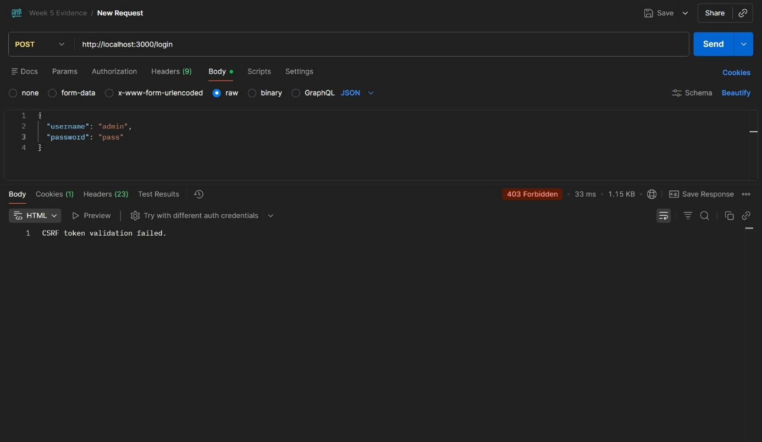
(403 response without CSRF token)
Screenshot: Postman With Fake Token error.jpg
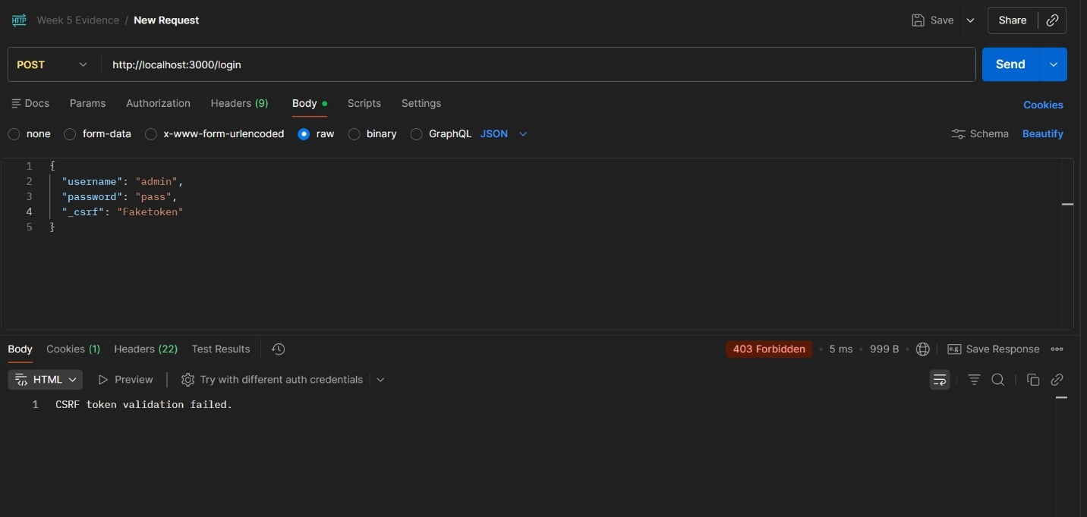
(403 response with invalid token)

Screenshot: Postman With Real token working.jpg
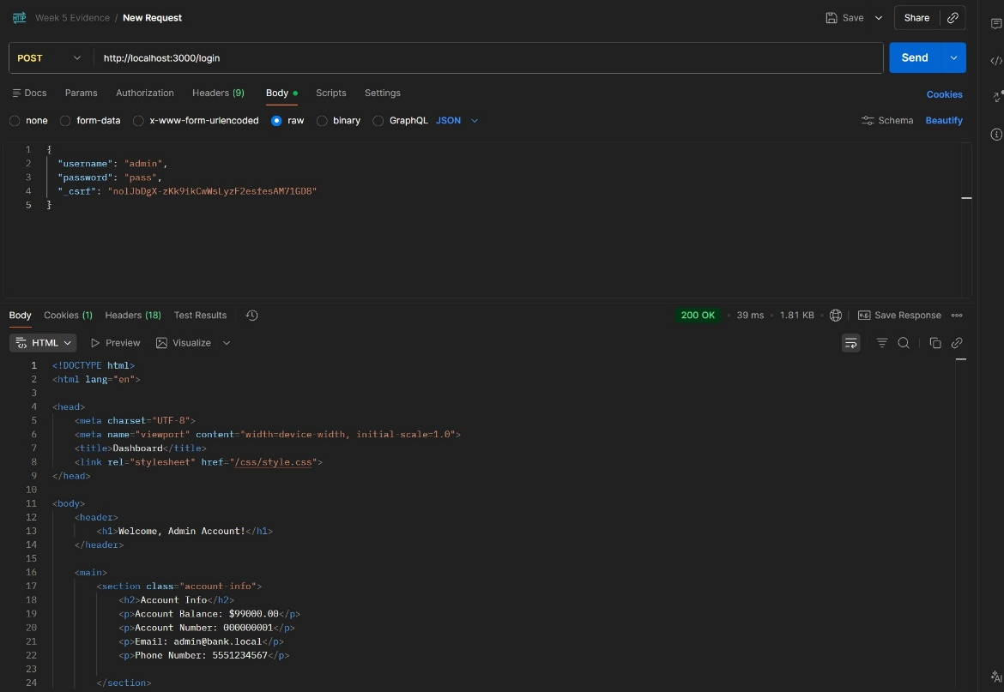
(Returned Dashboard page)

Validation Outcome
Authentication bypass was fully mitigated. Injection attempts were blocked by:
- CSRF enforcement
- Strict input handling
- express-mongo-sanitize
- Generic authentication responses
Layered defense successfully prevented exploitation.

7.3 Validation Scenario 2: Stored XSS Mitigation
Previously Observed Behavior (Week 5)
- Stored payload executed JavaScript
- Alert popup appeared
- Script persisted in database

Retesting Procedure
- Submitted original XSS payload through transfer memo
- Completed transfer
- Navigated to transactions page

Observed Results
- Payload rendered as plain text
- No alert popup appeared
- No JavaScript executed
- Script execution fully blocked

Screenshot: Showed memo XSS script on transfer funds page.jpg
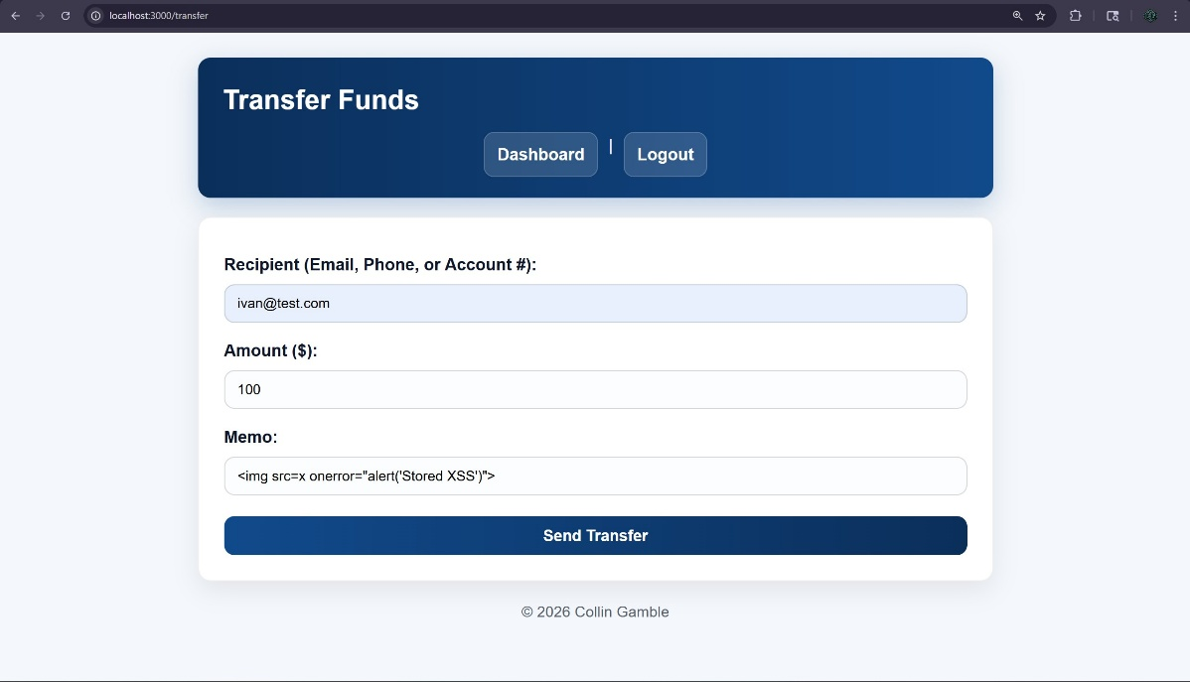
(Payload visible in memo field)

Screenshot: XSS script no alert popped up.jpg
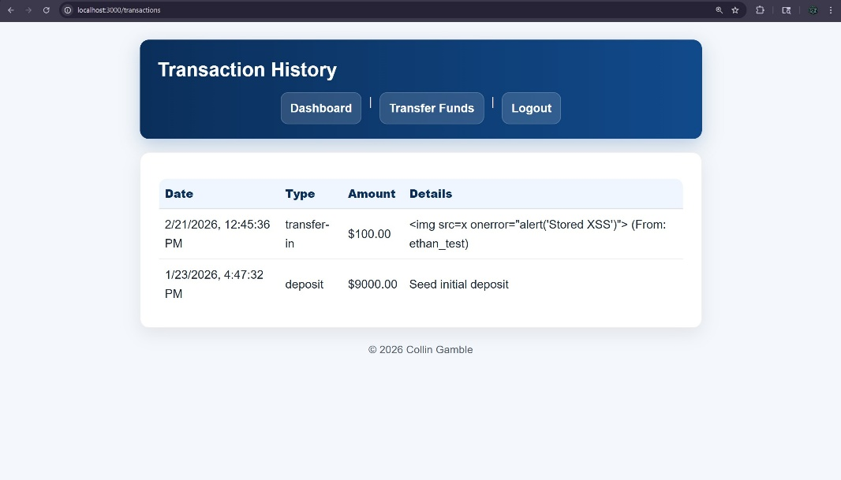
(Transactions page with inert payload)

Validation Outcome
Stored XSS was fully mitigated through:
- Escaped output rendering
- CSP enforcement
- Secure template handling
Even if malicious input was stored, execution was prevented.

7.4 Validation Scenario 3: Account Enumeration Prevention
Previously Observed Behavior (Week 5)
Distinct responses for:
- Nonexistent usernames
- Incorrect passwords
- Email mismatches

Retesting Procedure
- Attempted login with nonexistent username
- Attempted login with valid username + wrong password
- Attempted password reset with mismatched credentials

Observed Results
All authentication failures returned identical responses:
- “Wrong username or password.”
- “If the account exists, you will be able to reset your password.”
No internal state distinction was observable.

Screenshot: Login page wrong username or password error message.jpg
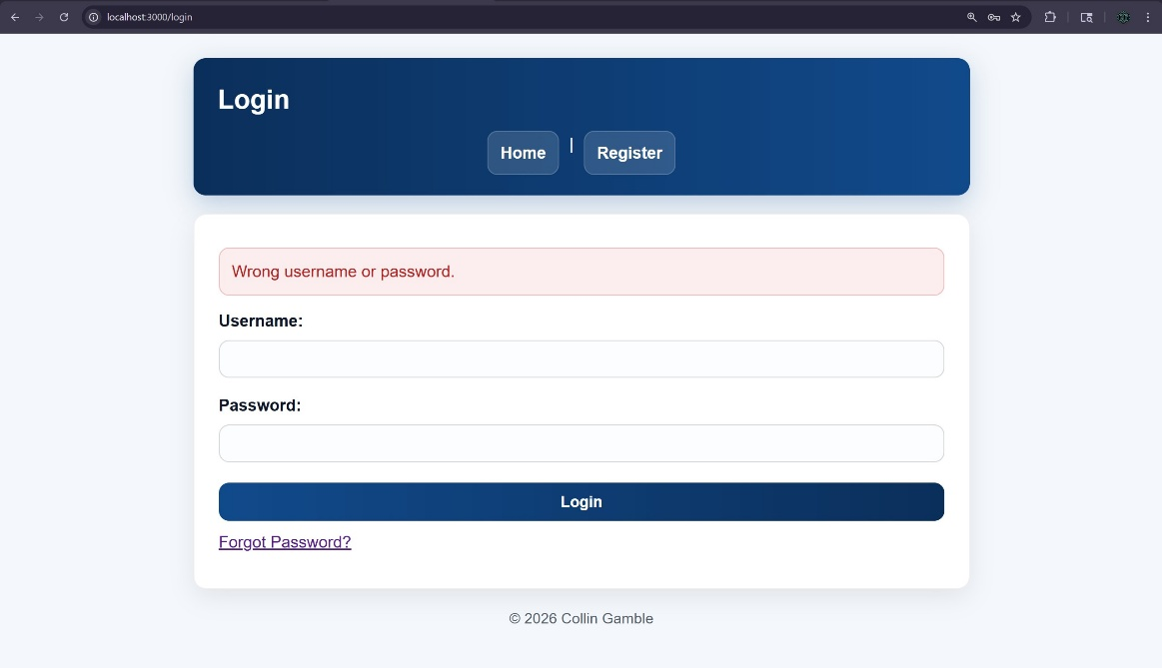
Screenshot: Forgot Password error message.jpg
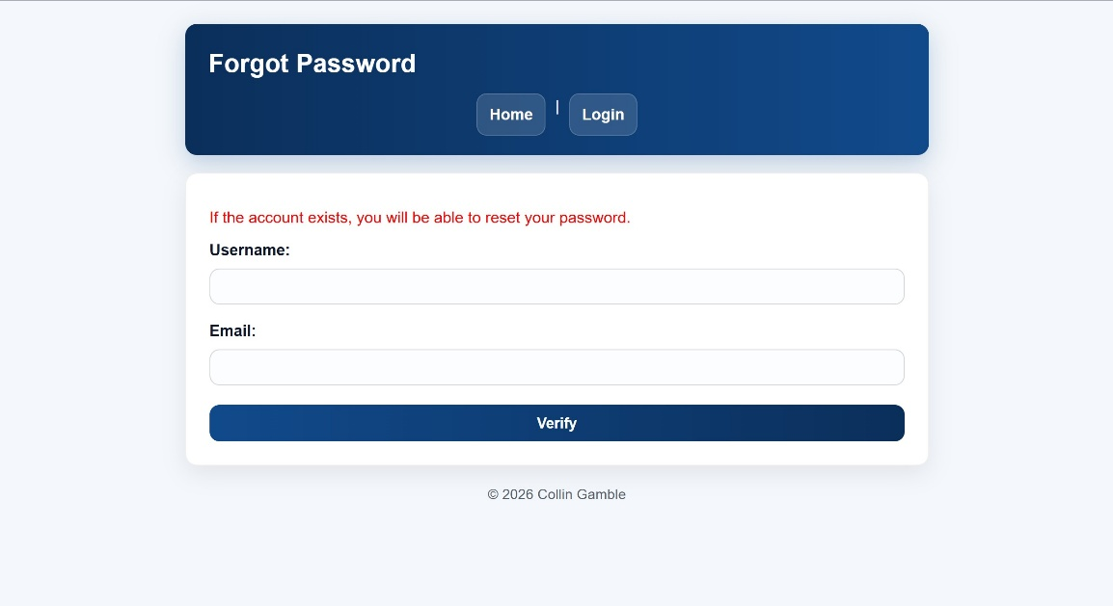

Validation Outcome
Account enumeration was eliminated. Attackers could no longer confirm valid usernames or email associations through response analysis.

7.5 Validation Scenario 4: Session Security Hardening
Previously Observed Behavior (Week 5)
- HttpOnly disabled
- Session cookie readable via document.cookie
- Vulnerable to chained XSS-based theft

Retesting Procedure
- Inspected session cookies in browser DevTools
- Attempted to access document.cookie
- Verified cookie attributes

Observed Results
- HttpOnly flag enabled
- SameSite policy active
- Session cookie inaccessible via JavaScript

Screenshot: Site cookies safe.jpg
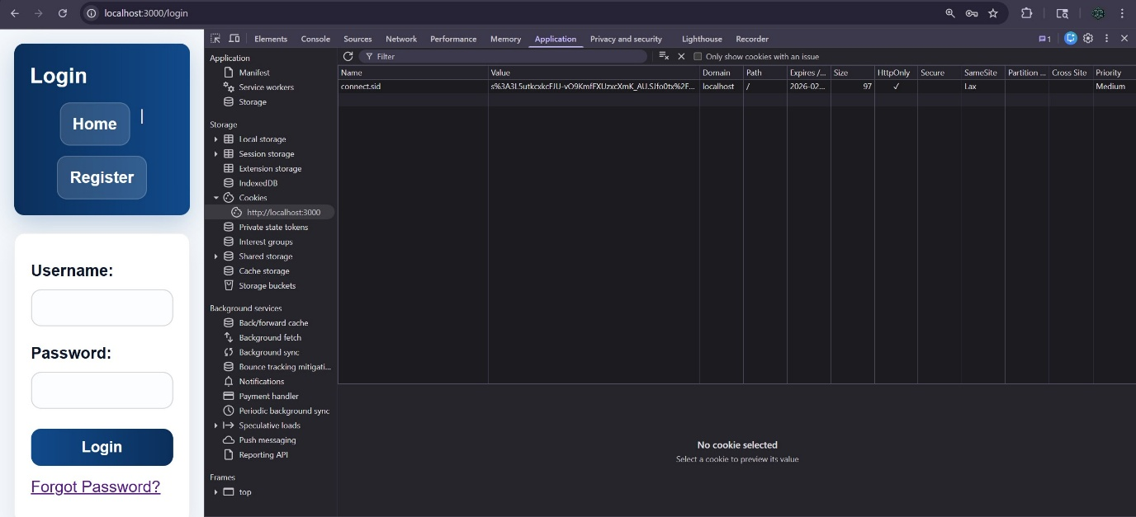
(Cookie showing HttpOnly and SameSite attributes)
Validation Outcome
Session hijacking via client-side script was no longer possible. The previously demonstrated chained attack was effectively neutralized.

7.6 Validation Scenario 5: Rate Limiting Enforcement
Retesting Procedure
Repeated login attempts exceeding configured threshold.

Observed Results
Server returned:
429 – Too Many Requests
Further authentication attempts were temporarily blocked.

Screenshot: Error 429 too many requests.jpg
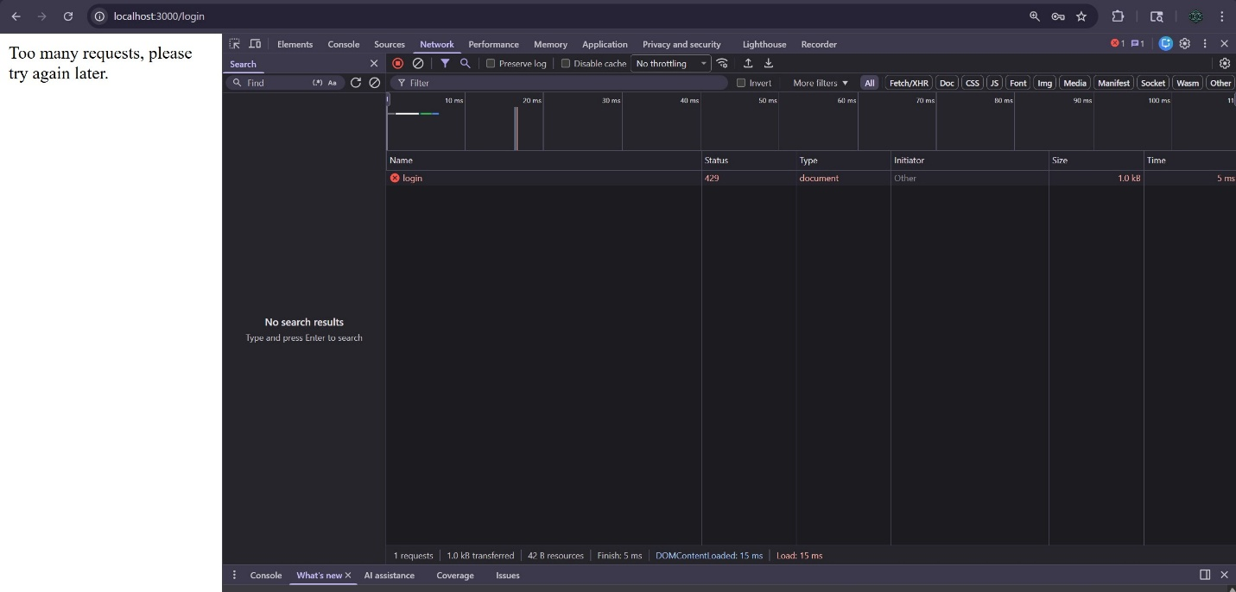

Validation Outcome
Brute-force mitigation controls were functioning correctly.

7.7 Security Posture Comparison
Vulnerability | Week 5 Result | Week 7 Result
NoSQL Injection | Authentication bypass | Blocked
Stored XSS | Script execution | Safely rendered
Account Enumeration | Username discovery | Generic response
Insecure Session | Cookie accessible | HttpOnly enforced
Brute Force | Unlimited attempts | Rate limited
This structured retesting confirmed that previously exploitable vulnerabilities were successfully mitigated.

8. Threat Modeling Analysis (STRIDE Framework)

8.1 Purpose of Threat Modeling
Following vulnerability remediation and validation, a formal threat modeling analysis was conducted using the STRIDE framework. While earlier phases focused on identifying and correcting known weaknesses, this phase examined the remediated system proactively to identify broader threat categories and evaluate residual risk.
The goals of this analysis were to:
- Identify system attack surfaces
- Categorize potential threats using STRIDE
- Map implemented mitigations to each threat category
- Evaluate residual risk
- Demonstrate defense-in-depth strategy
This analysis was performed against the fully remediated version of the application.

8.2 System Boundaries & Attack Surface
The secure application consists of the following primary components:
Client Layer
- Browser-rendered EJS views
- Form submissions (POST requests)
- Session cookie storage
Application Layer
- Express server
- Authentication & authorization logic
- Transfer funds logic
- Admin route enforcement
Data Layer
- MongoDB user collection
- Transaction records
- Role field
Security Middleware Stack
- Helmet (security headers + CSP)
- csurf (CSRF protection)
- express-rate-limit
- express-mongo-sanitize
- express-session
Primary Attack Surfaces
- Authentication endpoints (/login, /register, /forgot-password)
- Transfer endpoint (/transfer)
- Administrative routes (/admin/*)
- Session cookies
- Database queries
- User-controlled input rendering

8.3 STRIDE Category Analysis

8.3.1 Spoofing Identity
Definition: Impersonating another user or system component.
Potential Threats
- Authentication bypass via injection
- Session hijacking
- CSRF-based request forgery
Mitigations Implemented
- bcrypt password hashing
- Strict input typing in authentication logic
- express-mongo-sanitize
- CSRF protection via csurf
- HttpOnly session cookies
- SameSite cookie enforcement
- Generic authentication error responses
Residual Risk
Low. Authentication bypass and spoofing vectors were mitigated and validated during retesting.

8.3.2 Tampering With Data
Definition: Unauthorized modification of application or database data.
Potential Threats
- NoSQL injection altering queries
- Manipulated transfer amounts
- Forged POST requests
Mitigations Implemented
- express-mongo-sanitize
- Strict numeric validation for transfer amounts
- Server-side balance verification
- CSRF enforcement on all POST routes
- Role-based authorization middleware
Residual Risk
Low. Input validation and sanitization prevent query manipulation and transaction tampering.

8.3.3 Repudiation
Definition: Users denying actions without sufficient evidence to refute claims.
Potential Threats
- Disputed financial transfers
- Administrative misuse
- Undocumented login activity
Mitigations Implemented
- Transaction logging with timestamps
- Sender and recipient metadata
- lastLogin timestamp tracking
- Role separation for admin actions
Residual Risk
Moderate (lab scope limitation). While transaction records exist, production-level immutable audit logging was outside project scope.

8.3.4 Information Disclosure
Definition: Exposure of sensitive information to unauthorized users.
Potential Threats
- Account enumeration
- Stored XSS leaking session data
- Session cookie exposure
- Verbose error messaging
Mitigations Implemented
- Generic authentication error messaging
- Escaped EJS output
- HttpOnly cookie enforcement
- SameSite cookie configuration
- Helmet security headers
- Removal of verbose internal errors
Residual Risk
Low. Enumeration and XSS vectors were eliminated and validated.

8.3.5 Denial of Service (DoS)
Definition: Preventing legitimate access to the application.
Potential Threats
- Brute-force authentication attempts
- Automated request flooding
Mitigations Implemented
- express-rate-limit on authentication routes
- Request threshold enforcement
- Session expiration limits
Residual Risk
Low to Moderate. Distributed denial-of-service mitigation is outside scope of a local lab environment.

8.3.6 Elevation of Privilege
Definition: Gaining higher access rights than authorized.
Potential Threats
- Accessing admin routes as standard user
- Manipulating role fields
- Session-based privilege escalation
Mitigations Implemented
- requireAdmin middleware
- Server-side role validation
- No client-side role trust
- Protected administrative routes
Residual Risk
Low. Authorization checks are enforced server-side and validated through regression testing.

8.4 STRIDE Summary Table
STRIDE Category | Example Threat | Mitigation | Status
Spoofing | Authentication bypass | bcrypt, CSRF, session security | Mitigated
Tampering | Injection attacks | mongo-sanitize, validation | Mitigated
Repudiation | Transfer disputes | Transaction logging | Partially mitigated (lab scope)
Information Disclosure | Enumeration | Generic errors, HttpOnly | Mitigated
Denial of Service | Brute-force | Rate limiting | Mitigated
Elevation of Privilege | Admin abuse | Role middleware | Mitigated

8.5 Threat Modeling Phase Summary
The STRIDE analysis confirms that the remediated application addresses all six major threat categories through layered controls. This proactive evaluation complements exploit validation by ensuring the application is resilient not only to known attacks but to broader threat classes.
The system now reflects a defense-in-depth architecture rather than isolated vulnerability fixes.

9. Automated Security Validation (OWASP ZAP – Week 8)

9.1 Purpose of Automated Validation
After completing manual retesting and STRIDE threat modeling, automated security validation was performed using OWASP ZAP (Zed Attack Proxy) to independently evaluate the remediated application.
While manual testing confirmed that previously exploited vulnerabilities were mitigated, automated scanning provided:
- Independent vulnerability detection
- Configuration analysis
- HTTP header evaluation
- Content Security Policy review
- Route discovery through spidering
- Risk classification through standardized alert levels
The goal was to confirm that the secure version of the application no longer exposed high-risk vulnerabilities and aligned with OWASP Top 10 best practices.

9.2 Testing Methodology
Tool Used: OWASP ZAP 2.17.0 (Desktop Version)
Target: http://localhost:3000
Environment: Local Node.js / Express application
Scan Configuration
The following scanning process was performed:
- Automated spider to discover all accessible routes
- Passive scan of HTTP responses
- Active scan of discovered endpoints
- Review of all alerts by severity classification
- Content Security Policy hardening
- Second scan to validate configuration improvements
Security middleware active during scan:
- Helmet (security headers + CSP)
- CSRF protection
- express-rate-limit
- express-mongo-sanitize
- Hardened session configuration (HttpOnly, SameSite)

9.3 Initial Scan Results
The first automated scan produced:
- High Risk Alerts: 0
- Medium Risk Alerts: 3
- Low Risk Alerts: 0
- Informational Alerts: 3
No injection vulnerabilities, XSS issues, authentication bypasses, or CSRF bypasses were detected.

Screenshot: OWASP Test Scan Alerts Page.jpg
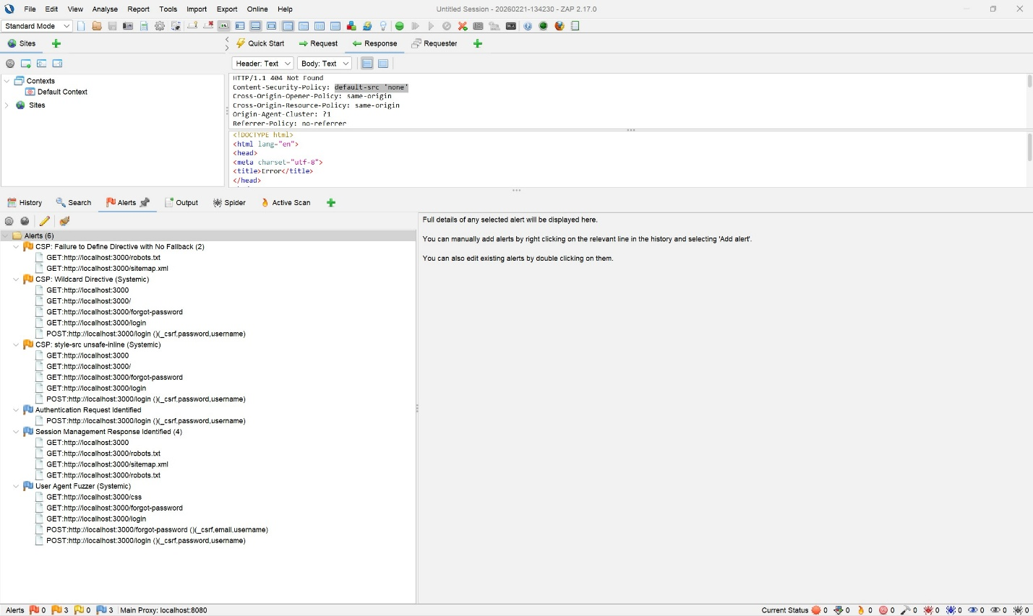
(Initial scan alert summary showing distribution)

9.4 Medium-Risk Findings (Configuration-Level)
The initial scan identified three Content Security Policy (CSP) recommendations:
- CSP: Failure to Define Directive with No Fallback
- CSP: Wildcard Directive (Systemic)
- CSP: style-src 'unsafe-inline'
These findings did not represent active exploitable vulnerabilities but indicated opportunities to strengthen CSP configuration.

Screenshot: OWASP Alert 1 CSP Failure to Define Directive with No Fallback.jpg
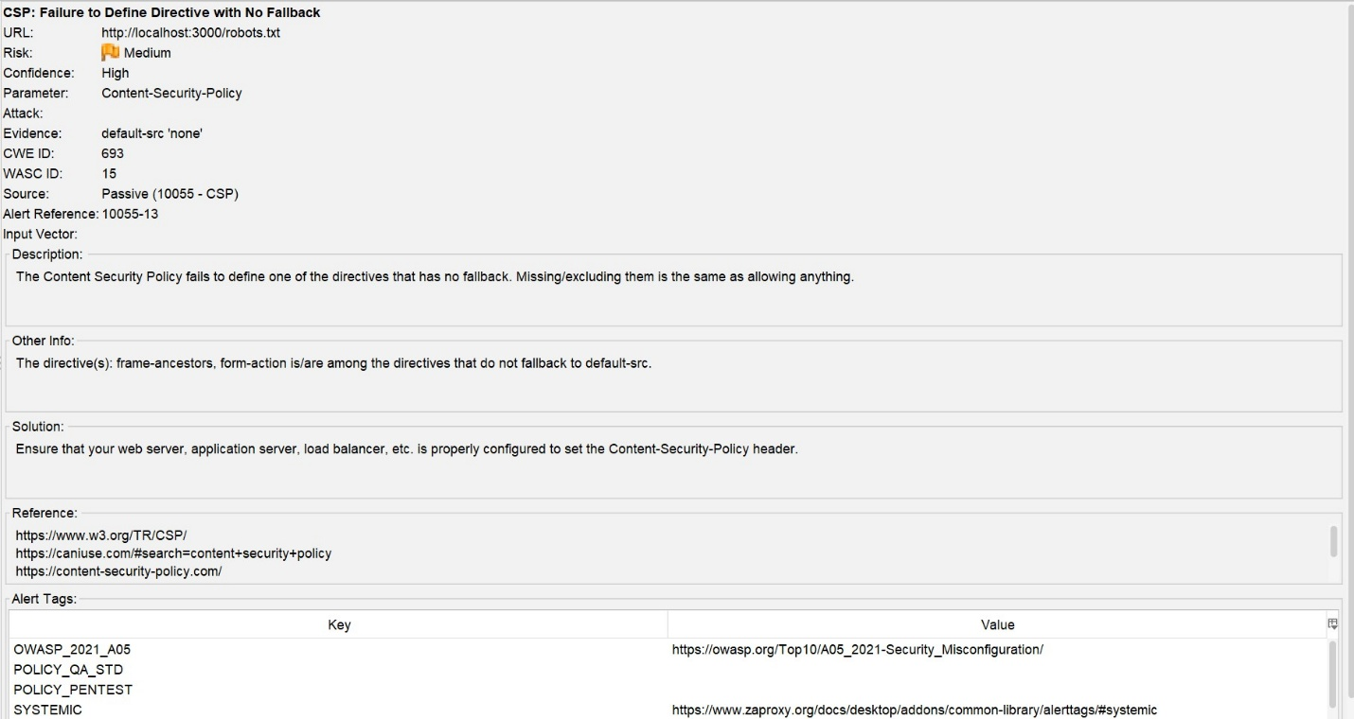

Screenshot: OWASP Alert 2 CSP Wildcard Directive.jpg
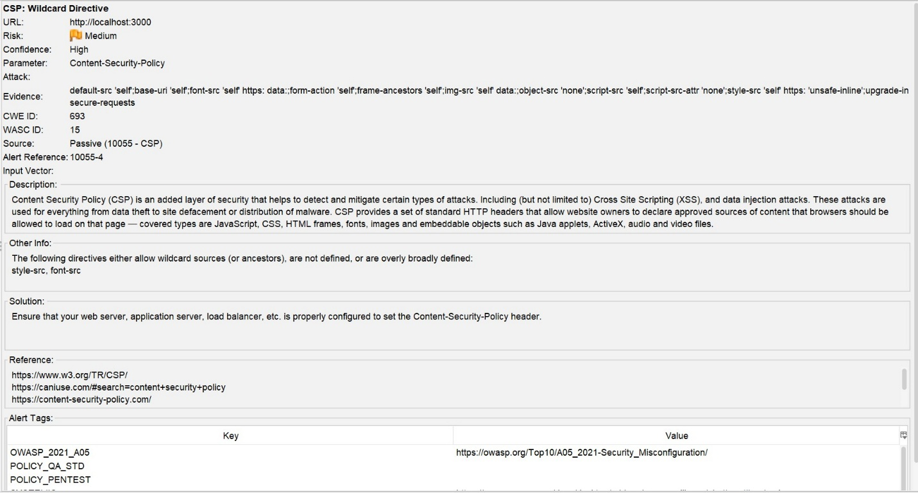

Screenshot: OWASP Alert 3 CSP style-src unsafe-inline.jpg
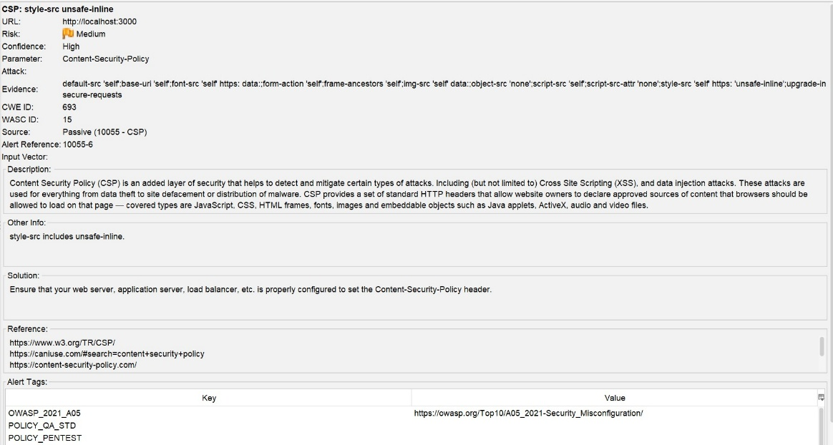

9.5 CSP Hardening & Revalidation
To improve configuration strength, the Content Security Policy was tightened to:
- Remove wildcard directives
- Reduce overly permissive allowances
- Improve default-src behavior
After applying these refinements, the automated scan was executed a second time.

Screenshot: OWASP 2nd Test Scan Alerts Page.jpg
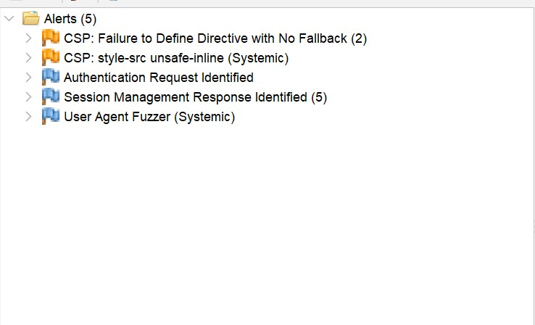
(Second scan showing removal of wildcard directive finding)
Observed Improvements
- The CSP Wildcard Directive finding was eliminated
- No High Risk vulnerabilities were detected
- Remaining findings were configuration recommendations only
- Informational alerts reflected route discovery and scanning activity
This demonstrated measurable security improvement following configuration hardening.

9.6 Validation of Previously Exploited Vulnerabilities
The automated scan did not detect:
- NoSQL injection vectors
- Stored or reflected XSS
- Authentication bypass
- Missing CSRF protection
- Insecure session cookie configuration
When combined with manual retesting (Week 7), this confirms that vulnerabilities intentionally introduced in Week 4 were fully mitigated.

9.7 Security Posture Comparison
Category | Vulnerable State (Week 5) | Secure State (Week 8)
NoSQL Injection | Exploitable | Not detected
Stored XSS | Executable | Blocked
Account Enumeration | Possible | Prevented
Session Cookie | HttpOnly disabled | HttpOnly + SameSite
CSRF Protection | Absent | Enforced
CSP Wildcard | Present | Removed
Automated Scan Risk | Multiple weaknesses | 0 High Risk Findings
The measurable reduction in findings confirms effective remediation and configuration refinement.

9.8 Automated Validation Summary
OWASP ZAP validation demonstrates that the remediated application:
- Contains no high-risk vulnerabilities
- Successfully blocks previously demonstrated attack vectors
- Implements strong session security
- Enforces CSRF protection
- Uses hardened CSP configuration
- Reflects layered defensive architecture
Automated scanning reinforces the results of manual validation and threat modeling, establishing a secure baseline configuration.

10. Final Security Posture Assessment

10.1 Security Lifecycle Summary
This Capstone project demonstrates a complete web application security lifecycle:
- Functional system development
- Intentional vulnerability introduction
- Controlled exploitation
- Root cause analysis
- Structured remediation
- Manual validation
- Threat modeling
- Automated validation
The final system reflects measurable improvement in security posture across authentication, input handling, output rendering, session management, and configuration hardening.
Rather than relying on isolated patches, the secure implementation integrates layered defensive controls aligned with industry best practices.

10.2 Defense-in-Depth Evaluation
The remediated application employs multiple overlapping security controls:
Authentication Security
- bcrypt password hashing
- Strict type validation
- Generic error responses
- CSRF token enforcement
Injection Prevention
- express-mongo-sanitize
- Input validation
- Escaped template rendering
Session Security
- HttpOnly cookies
- SameSite policy enforcement
- Server-side session validation
Availability Protection
- express-rate-limit
- Threshold-based request blocking
Configuration Hardening
- Helmet security headers
- Content Security Policy refinement
Each layer reduces exploit feasibility even if another control were to fail. For example:
- Even if XSS were reintroduced, HttpOnly cookies prevent session theft.
- Even if input validation were bypassed, mongo-sanitize reduces operator injection.
- Even if brute-force attempts occur, rate limiting limits abuse.
This layered architecture reflects defense-in-depth principles.

10.3 Alignment with OWASP Top 10
The project intentionally addressed several OWASP Top 10 categories:
OWASP Category | Demonstrated | Mitigated
A03 – Injection | Yes | Yes
A05 – Security Misconfiguration | Yes | Yes
A07 – Identification & Authentication Failures | Yes | Yes
Automated scanning confirmed that no high-risk OWASP-aligned vulnerabilities remain detectable in the final version.

10.4 Residual Risk Considerations
While the application demonstrates strong security posture within a lab environment, several production-level considerations fall outside project scope:
- Distributed Denial-of-Service mitigation
- Centralized immutable logging
- TLS certificate configuration
- Multi-factor authentication
- Production-grade monitoring
- Secure DevOps pipeline integration
These exclusions are consistent with the project’s educational focus and local-only deployment.
Residual risk is considered low within the context of the lab environment.

10.5 Professional Evaluation
From a security engineering perspective, the final system:
- Enforces secure authentication practices
- Eliminates injection vectors
- Prevents account enumeration
- Hardens session configuration
- Implements layered middleware controls
- Passes automated scanning with zero high-risk findings
- Demonstrates measurable security improvement from baseline
The system has transitioned from intentionally vulnerable prototype to defensively engineered secure application.

11. Lessons Learned

11.1 Technical Growth
This project reinforced the importance of understanding vulnerabilities at the root cause level rather than treating them as abstract concepts.
Key technical lessons include:
- How MongoDB operator injection occurs
- Why output encoding must never be optional
- How small configuration changes (HttpOnly) significantly impact risk
- Why verbose error messaging weakens authentication systems
- How middleware layering reduces exploit feasibility
- The importance of validating mitigations, not assuming effectiveness

11.2 Security Mindset Development
A major takeaway from this project was the transition from:
“How do I make this work?”
to
“How could this be broken?”
Security is not a feature added at the end of development. It must be integrated throughout the lifecycle.
This project emphasized:
- Proactive threat modeling
- Defensive coding practices
- Structured retesting
- Automation-assisted validation
- Measurable before-and-after comparison

11.3 Understanding Chained Risk
One of the most impactful lessons was observing how vulnerabilities interact.
Stored XSS alone did not grant account takeover.
Insecure session cookies alone did not grant access.
Combined, however, they created high-risk conditions.
This reinforced the importance of layered security and defense-in-depth strategy.

12. Conclusion
This Capstone project successfully demonstrates a complete web application security lifecycle within a controlled local lab environment.
Beginning with a functional banking-style prototype, the system was intentionally weakened to include injection flaws, stored XSS, authentication weaknesses, and insecure session configuration. These vulnerabilities were exploited using structured testing methodologies to demonstrate real-world impact.
Following controlled exploitation, remediation strategies were engineered using secure coding practices and industry-standard middleware controls. Previously successful attack payloads were systematically re-executed to confirm mitigation effectiveness. Threat modeling and automated validation further strengthened confidence in the system’s defensive posture.
The final secure version of the application:
- Eliminates previously demonstrated vulnerabilities
- Implements layered security controls
- Aligns with OWASP Top 10 principles
- Produces zero high-risk findings under automated scanning
- Demonstrates measurable improvement from baseline
This project reflects not only technical implementation skill but also a comprehensive understanding of offensive testing, defensive engineering, and structured security validation.

13. AI Assistance Disclosure
Portions of this report, including organization, structural refinement, and clarity improvements, were developed with the assistance of AI (ChatGPT). AI was used to help:
- Organize technical content into a cohesive formal report structure
- Refine wording for academic clarity and professional tone
- Improve formatting consistency
- Assist with summarizing previously written documentation
All technical implementation, vulnerability design, exploitation, remediation, testing, validation, threat modeling, configuration changes, screenshot collection, and analysis were performed independently by the student.
AI tools were not used to generate application code or execute testing activities. All security decisions, architectural design choices, and validation processes reflect the student’s direct work and understanding.

